Winter 2022 // WEEK 8
Life Group Questions
Acts: Daring To Be The Church // March 5-6, 2022
Storms Are Part of the Calling // Acts 27:1-44

Introduction
With the trial before Agrippa over, Paul sets sail as a prisoner on a ship bound for Italy. Given the significance of Paul’s mission to share the Gospel with the Emperor in Rome, we might expect God to pave the way for a quick and safe journey. However, Luke details a voyage in Acts 27 that is anything but smooth. There are lessons for us to learn about responding to the storms of life as we observe Paul’s response this week.

To think through the main ideas in the sermon and prepare for your discussion together, we invite you to look over the questions below and write your thoughts down before you meet with your group.

Warm Up (Suggested time: 30 min)
Here are some suggestions to get your conversation started:
- If you were given $100,000 to celebrate someone or something, who or what would you celebrate and how might you go about it?

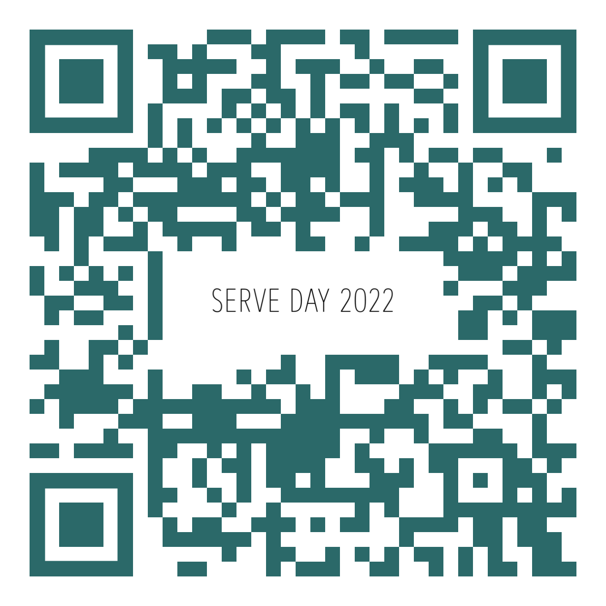
- Sign-ups for Serve Day 2022 are live on March 6th! Take time to either propose a project or to look through opportunities on the website and discuss where/how you want to serve. We encourage you to take the time to sign-up while you are meeting. Use this QR Code to sign-up.
Or here is a link to the website: https://www.lincolnberean.org/serveday

Getting Started
Transition into group discussion.
- Open group discussion with prayer. Here are a few potential prayer items:
  - For the Spirit of God to lead you in truth
  - For the fruit of the Spirit to be cultivated in your lives
  - For grace to hear and apply what the Spirit says to you
- Invite someone to read the passage in the group. Due to the lengthy passage of Scripture this week, try referring to the narrative as guided by the discussion questions

Study Questions (Suggested time: 40 min)
- What did you sense the Holy Spirit impressing on your heart from this passage or the sermon?

- Read Acts 27:1-9 and 2 Corinthians 11:23-30. These kind of circumstances have defined the life and mission of Paul since his conversion. Based on the message this weekend, would we conclude that these circumstances were evidence that Paul was out of God’s will or that they were part of his calling? Explain your answer.

When have you struggled with determining whether you were in God’s will based on your circumstances? Why is this a dangerous thing to do?

- Read Acts 27:9-21. In most cases Paul’s struggles were from the hands of those opposed to the Gospel he was proclaiming. However, in this narrative the struggles are really a result of factors only God could control. What do we learn from this?

Are struggles and storms simply challenges we must endure because we live in a fallen world or are some of them actually strategically created or allowed by God in order to accomplish the missions we’ve been given? Explain your answer.

How have you seen God use struggles or storms in your own life to grow and transform you?

How have you seen God use struggles or storms in your life as a means of influencing others towards the Gospel?

- Read James 1:2-5 and Romans 5:3-5. What do these verses have to say about responding to the struggles and storms of life?

Paul lived as an agent of hope throughout this storm because he believed strongly in the sovereignty of God. Read Acts 27:21-37. Where do you see Paul being hopeful and encouraging in these verses?

What would it look like to live as agents of hope in the harsh culture of our day?

Prayer (Suggested time: 20 min)
A significant part of “coming together” is being open and honest with our lives. Sitting in a group of people for prayer may be new or it may be familiar to you. If you would rather not pray aloud when it is your turn, feel free to pray silently and then say “Amen” aloud signaling the next person in the group to pray. Whether or not you choose to verbalize your prayer, everyone is a participant in sharing this time before God together.

Is anyone going through a storm right now? Pray God’s purposes will be accomplished through the storm and that God’s peace and assurance would be felt in the midst of the storm.

Some things to consider during prayer time:
- What did the message or group discussion cause you to notice about your relationship with Jesus?
- How can you express gratitude for what God’s teaching you?
- What questions are stirring that only God can answer?
- Are there troubling things in your life that need to be confessed to God?
- Is there an unmet need that only God can fulfill?

Personal Spiritual Exercises
Just like physical exercises help strengthen and stretch our bodies for healthy living, these spiritual exercises are meant to move us spiritually in ways that may be new so we might experience inner growth. Since God longs for us to experience Him with our whole selves – mind, body, spirit – we invite you along each week to strengthen your souls with suggestions and prompts. Next week in your Life Group, take a few moments to share how either of these exercises may have changed your outlook on your daily life.

Sitting With God: Imagine having a cup of coffee with Jesus. Review the people, events and happenings of the last few days. Ask Jesus to speak to you about your life. What things does Jesus seem to be pointing out to you?

Soaking in the Word: For most of us, learning is the goal when we read scripture, but in this context we simply want to hear what God is saying; to listen, feel and experience the Words of Christ washing over you.
Read Matthew 6:19-34 (or listen on a Bible app if you have one) for 5 days in a row, perhaps from different versions. What words or phrases seem to be emphasized? Ask Jesus, “What do I need to know today about my life with you?

