SPRING 2025** // WEEK 6

**Life Group Questions**   
Everyday Disciples // May 10/11, 2025

Busyness // Proverbs 23:1-5, 1 John 2:15-17, Matthew 6:33

Don’t forget the Life Groups Picnic Celebration scheduled for Sunday, May 18th! We invite you to come together for an old-style Pot Lunch meal to celebrate all that God has done in Life Groups this past year. Weather permitting we’ll enjoy outdoor games and activities and there will be a few ways to share some of what God has done in your life through your Life Group this year. The Life Groups Team is providing the main meat dish. When you register, let us know how many are attending (including kids) and also what side dish you are bringing. We also need to know allergy notes related to your dish (i.e. your side dish contains gluten or dairy, etc.). The link to sign up is: <https://www.lincolnberean.org/LG-picnic>

**Introduction**

As we are learning what it means to live as disciples of Jesus, we’ve noticed that it takes intention and effort. In our hectic and hurried culture, wrestling with the impulse toward *busyness* is common for all of us. Pastor Bryan took us to passages in the Old and New Testaments to show us how to understand the root issue in this struggle.

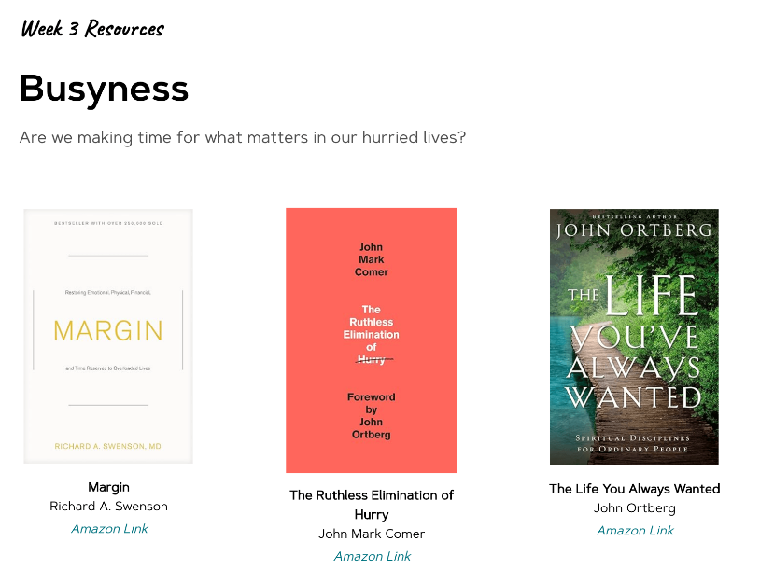

In addition to the sermon and these discussion questions, LBC is recommending resources each week that you could look at if you want to dig further into this topic. **After the sermon each weekend**, you can find links to these resources on our website. To the left is a picture of the resources for this week. There are no links to these resources here. Here is a link to the webpage: [www.lincolnberean.org/everydaydisciples](http://www.lincolnberean.org/everydaydisciples)

**We invite you to look over all the questions on the following pages and write your thoughts down before you meet with your group. Some people even use these questions to take notes during the sermon. The questions are meant to stir your thinking and prompt open discussion, and we do not expect you to cover every question each week.**

**Warm Up** *(Suggested time: 30 min)*

1. What song on your playlist (or the radio) is meaningful to you lately? Share it with the group.
2. Would you rather have a remote control that can pause time or fast-forward through boring moments?

**Getting Started**

Transition into group discussion.

1. Open group discussion with prayer. Here are a few potential prayer items:
   1. For the Spirit of God to lead you in truth
   2. For the fruit of the Spirit to be cultivated in your lives
   3. For grace to hear and apply what the Spirit says to you
2. Choose someone to read the passage aloud for the group or read them as you come to them in the questions.

**Study Questions** *(Suggested time: 40 min)*

1. **What has surprised or inspired you about our series, Everyday Disciples?**
2. Pastor Bryan described the *busyness* in our culture. **What are some factors that drive that busyness?**

**When you think about your own schedule and pace of life, would you rate yourself as too busy, not busy enough, or just right? Give an example, if possible.**

1. Read Proverbs 23:1-5 and 1 John 2:15-17and notice the warning they give us. **What is the great risk we all face according to these verses?**

**What’s the relationship between busyness and the search for significance?**

1. It’s one thing to keep a full social calendar, but busyness has a way of creeping into all areas of life. **What are some reasons why you might bring busyness into your spiritual life?**

Read Matthew 11:28-30 together (reading in the Message paraphrase might be fun). **What does Jesus offer to all of us who have made our spiritual life a hectic performance?**

**To what extent are you experiencing the kind of relationship Jesus offers?**

1. Both overwork and laziness are components of our culture, and neither are God’s desire for us. Matthew 6:33 says, “But seek first His kingdom and His righteousness, and all these things will be provided to you.” **In your own words, describe what it means to “seek first His kingdom and His righteousness”.**

**How might knowing and acting on these words of Jesus keep you from being ruled by busyness?**

**What can you do as a Life Group to encourage each other in this area of discipleship?**

**Personal Spiritual Exercises**

Just like physical exercises help strengthen and stretch our bodies for healthy living, these spiritual exercises are meant to move us spiritually in ways that may be new so we might experience inner growth. Since God longs for us to experience Him with our whole selves—mind, body, spirit—we invite you along each week to strengthen your souls with suggestions and prompts.

**Scripture Focus**: In Matthew 5:1-12 Jesus describes the value system of His Kingdom. Make a plan to read this passage each day and take note of the words that are most meaningful each time. When you get to the end of the week, journal a response to all that God taught you in that simple act of faithful reading. God’s Word is living and active!

**Prayer Focus**: A good way to resist busyness is being intentionally silent and still to focus on God. Try setting a timer for 10 minutes. Sit upright but comfortably in a chair with your palms open and upward on your lap. Focus on a word or short phrase about the character of God the Father, Son, or Holy Spirit. When your thoughts wander to the things on your to-do list or other people’s needs, redirect them back to the character of God. When the 10 minutes is up, close in a short prayer of gratitude.

**Prayer** *(Suggested time: 20 min)*

A significant part of “coming together” is being open and honest with our lives. Sitting in a group of people for prayer may be new or it may be familiar to you. If you would rather not pray aloud when it is your turn, feel free to pray silently and then say “Amen” aloud signaling the next person in the group to pray. Whether or not you choose to verbalize your prayer, everyone is a participant in sharing this time before God together.

Take a few moments to prepare a prayer request. What did the message, working through the above questions or the discussion cause you to notice about your own relationship with Jesus? Would you be willing to share your prayer request with the group?